McCreary HOA Website

Old Information on Homepage

1/16/16-
The McCreary Creek Estates Home Owner's Association Board is proud to present the Jan 2016 Newsletter
Please let us know if you find the included information helpful and make recommendations for content you would like to see included in future versions.
MCE HOA January 2016 Newsletter
1/2/16-
City of Parker Planning and Zoning Meeting, Jan 6, 2016 @ 7:00 pm, City Hall
Please mark your calendar and attend if possible.
The Planning and Zoning Commission for the City of Parker will hold a special meeting for the consideration and / or to take appropriate action regarding the development plat / preliminary engineering plans for the proposed Storage Facility directly West of McCreary Creek Estates on McCreary Rd.
More information on the City of Parker website | Agenda
1/1/16-
McCreary Creek Estates Home Owner's Association Welcomes New Board Members
The MCE HOA is pleased to announce the addition of two new board members.
Philip Steiman - 7305 Forest Bend Dr.
Phil has extensive experience working in and around home owner associations. He is well connected within the local government arena and regularly participates in city council meetings. Phil has also been involved in facilitating local improvements such as the Welcome to Parker signage just South on McCreary Rd.
Dr. Nishith Tripathi - 7406 Forest Bend Dr.
Nishith has a background in engineering, training and leadership. He brings energy and enthusiasm to the board. Nishith wishes is to focus on neighborhood security, finances, goals and communications / reporting.
We welcome the addition of these gentlemen to the board and look forward to the continuation of our pursuits to meet the responsibilities and challenges of the MCE HOA.
Modifications to individual board titles and responsibilities are forthcoming and will be announced soon.
Joann Hadaway and Ted Niederecker have completed their board terms and we thank them for their hard work. Their efforts were instrumental in the transition of board accountability from the developer and management firm to the duly elected neighborhood HOA board. Their achievements are many and include budget optimizations, numerous entryway landscaping / lighting improvements / signage and rallying participation on zoning issues as well as ongoing daily administrative attention to discipline.
Happy New Year!
Best regards,
Jody
12/23/15-
Holiday Social Photos & Seasons Greetings!
Wishing you and your family a wonderful holiday season.
Photos from the McCreary Creek Estates 2015 Holiday Social Event:
http://www.mcehoa.net/pages/photos.html?id=27857
*If you attended and would like to add photos you took at the event, feel free to do so!
Best regards,
Jody
12/01/15-
MCE HOA Holiday Social
Please Note: the social event will be held at the Murphy Activity Center, not the Murphy Community Center where past social events and HOA meetings have been held.
The Murphy Activity Center is Next door to the Murphy Community Center.
Please RSVP to Mary Urquidez, MCEHOA Social Committee Chairman by 12/10/15 or sooner at:
(940) 224-0038
or
mary.urquidez@gmail.com
11/11/15-
MCE HOA Meeting and Board Election News
The annual meeting of the association was held last night to approve meeting minutes from the previous year, review accomplishments of the board & community, review next year's budget, award appreciation plaques to the two outgoing board members who have fulfilled their one year terms; Joann Hadaway and Ted Niederecker and to vote in two new board members.
There were only two nominees for the vacated board positions which resulted in them being assigned the duty by default, therefor no election.
Please welcome the two new members of the MCE HOA board who will begin their two year terms on January 1, 2016: Phil Steiman & Nishith Tripathi.
11/02/15-
MCE Annual Meeting of the Association - Please attend or assign your Proxy vote
In accordance with Article X of the Bylaws of the McCreary Creek Estates Homeowners Association, Inc., the Annual Meeting of the Association shall be held on:
Tuesday, November 10, 2015
at 6:30 p.m. (Sign-in from 6:00 - 6:30 p.m.)
City of Murphy Recreation Center
Marie Adams Room
206 N. Murphy Road, Murphy, TX 75094
The business to be conducted is the election of two (2) Directors and the agenda for the meeting is as follows:
A. Call to Order
a. Introductions
b. Confirmation of Quorum
B. Approval of the 2014 Annual Meeting Minutes
C. Board Report/Accomplishments
D. Financial Report
E. Nominations from the Floor
F. Candidate Presentations
G. Balloting
H. Election Results
I. Adjournment
J. Questions and Answers
If you cannot attend:
Please return a proxy form by fax to (972) 458-2203 or mail to 12700 Hillcrest Road, Suite 234, Dallas, Texas 75230 or by email to vickie@guardianllc.net so that it is received by 3:00 PM November 6, 2015. You may also give your fully executed proxy to the person whom you wish to assign it or have it brought to the meeting to present for quorum and voting of directors.
Here is a link to the form: 2015 Annual Meeting Proxy Form
NOTE: It is very important that you return a proxy form if you are unable to attend the meeting, so that the quorum requirements can be met. i.e. to have the required number of residents and proxy representatives present to participate in the meeting and vote 2 (two) new board members in.
10/09/15-
McCreary Creek Estates National Night Out Celebration
A BIG thank you to the McCreary Creek Estates Board of Directors and the residents of McCreary Creek Estates for making the recent block party celebrating National Night Out such a huge success!
Mayor, Z Marshall, Council Woman, Lee Pettle, Chief of Police, Bill Rushing and his staff, and Chief of the Parker Volunteer Fire Dept., Mike Sheff and his staff were all in attendance on Tuesday, Oct., 6, 2015 to answer any questions that the residents had concerning police and fire services. Twenty-three residents and their families participated this year. They were treated to free ice cream and drinks, a bounce house, and music!
The National Night Out Celebration scheduled on Tuesday, October 6, 2015 from 6:00 – 8:00 p.m. took place on the East intersection of Meadow Glen Dr. and Forest Bend Streets. A BIG thank you also to the residents in that corner who so graciously attended and accepted the inconvenience of their street blocked off to thru traffic and offered electrical services for the lighting necessary that evening.
National Night Out is the first step in building a strong community network of active, involved citizens, equipped to participate in anti-crime efforts throughout Parker. The MCEHOA BOD and the MCE Social Committee members along with the Parker Police Department and Fire Department Fire-Rescue provided public safety displays and activities.
Everyone is looking forward to celebrating next year’s National Night Out block party!
Mary Urquidez – McCreary Creek Board of Directors- Chairman of the Social Committee
Link: Photos from the event
MCE Residents and attendees of the event, fee free to upload your pictures to the library!
10/6/15-
McCreary Creek Estates National Night Out Celebration
Just a reminder. National Night Out Celebration is scheduled for Tonight, Tuesday, October 6, 2015 from 6:00 – 8:00 p.m. Residents are invited to the East intersection of Meadow Glen Dr. and Forest Bend Streets to celebrate the event.
The Parker Police Department and the Parker Volunteers Fire Department have been invited by the MCEHOA Directors to celebrate National Night Out with the residents.
National Night Out is the first step in building a strong community network of active, involved citizens, equipped to participate in anti-crime efforts throughout Parker Join the MCEHOA BOD and the MCE Social Committee along with the Parker Police Department and Fire Department Fire-Rescue for public safety displays and activities, free ice cream and drinks, a bounce house, and music!
9/4/15-
Parker City Council Recent Activities:
The Parker City Council met on September 1, 2015 and took the following actions:
Public Comments:
Sharon Macduff: has lived in Parker since 1976 and now has an issue with her neighbor’s field which she believes is in violation of our city ordinance requiring grasses to be no higher than 12” tall. She reported this to Code Enforcement on 8/10/15 and to Jeff Flanigan and just got a response yesterday when she was told there was not much that could be done. She stated this is unacceptable. If she is not reading our city ordinance correctly, she asked that it be explained her otherwise please enforce our ordinance.
Authorized the Mayor to offer the position of City Secretary to Patti Scott Gray, subject to Ms. Gray’s clearing a background investigation and drug test.
Approved amending the street maintenance agreement to include Dublin Road and Gregory Lane.
Approved the continuation of the agreement with the City Depository Bank for credit card services and confirms approval for three city employees to have use of credit cards.
The employees are City Administrator Jeff Flanigan, Finance Director Johnna Boyd and Police Chief Bill Rushing.
Approved designating the Dallas Morning News as the official newspaper for the city of Parker for the fiscal year 2015-2016.
Approved entering into a service agreement with BrooksCardiel, PLLC for the 2014-2015 financial audit of the City.
Public Hearing - Budget
Tom Macduff asked if the City has met its revenue and expenses projections in the past and if there is a residual balance, what happens to those funds. Mayor Marshall responded indicating the City has met its revenue and expense projections in past years and any monies left are placed in an unrestricted reserve account. Mr. Macduff asked about speed bumps at some point for Sycamore Lane as the bicyclers are causing traffic hazards for cars, horses and pedestrians. Mr. Macduff was invited to present information regarding the speed bumps at the city’s upcoming planning session.
Approved the City’s tax rate at $0.350984 per $100.00. This is the same rate as the last two years, see attached.
Approved the City’s budget for fiscal year 2015-2016 on a 4 to 1(Pettle) vote. See attached.
Approved appointing a subcommittee to review subdivision regulations. Appointed Council Member Tom Stone, City Engineer John Birkhoff, City Attorney Jim Shepherd and City Administrator Jeff Flanigan to the subcommittee which shall present their recommendations to Council when ready.
Canceled City Council meetings on October 6, 2015 as that is National Night Out and on November 6, 2015 as that is Election Day and Council chambers will be in use for voting.
Planning Session for the City of Parker will be scheduled to occur probably in early November depending on the availability of the Mayor, Council Members, staff and Council chambers. Will advised when date set.
8/19/15-
Update on the Parker Ministorage LLC
THANK YOU for all the residents in attendance and all the emails that went to the city council that were recognized by the mayor----the plat was DENIED!!!!!

The city engineer found problems with the plat in regards to drainage, flow, acreage amounts being incorrectly stated, corner monuments not designated, and numerous more.
Now all this has bought us is time to launch our next strategy which will involve the county commissioner AND possibly litigation among other strategies being discussed.
Please stay posted, we will continue to communicate by email blast but email us anytime at board@mcehoa.net if you'd like to get a live update or even better:
GET INVOLVED
8/14/15-
CALL FOR EMAIL - Parker Storage
Your city council and mayor want to hear from every concerned resident prior to the city council meeting in the matter concerning the development of the property into mini storage facility. Please join us in taking time to express your opinions and concerns to each member:
If you go to the city website, select government tab then city council and look at the bottom, you can send one email to all members by clicking on the words “city council” :
For more information, contact the City Council.
Or you can email each one:
zmarshall@parkertexas.us
slevine@parkertexas.us
tstone@parkertexas.us
ptaylor@parkertexas.us
estandridge@parkertexas.us
lpettle@parkertexas.us
Sincerely,
McCreary Creek Estates HOA Board Members
Rajiv Gaind
Ted Niederecker
Jody Low
Mary Urquidez
Joann Hadaway
8/13/15-
Update on the Nearby Proposed Storage Facility
Concerned homeowners and HOA representatives from nearby neighborhoods met on Tuesday, Aug 11 and discussed plans and actions to prevent the construction of the proposed storage facility across McCreary Rd. Various strategies were discussed. More details will be distributed when available.
Make your voice heard. Please attend the Parker City Council Public Hearing where the issue will be discussed. The more we have the better. August 18th, at 7 pm at City Hall.
8/4/15-
Notice of Zoning Meeting
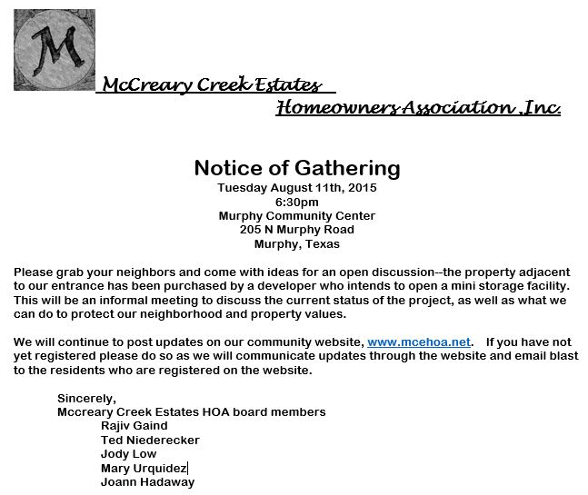
7/22/15-
Urgent zoning issue - planned Storage Business near McCreary Creek Estates Subdivision
The City of Parker Planning and Zoning Commission has a meeting scheduled tomorrow, July 23 at 7:00 pm at Parker City Hall to discuss consideration and appropriate action for:
**A DEVELOPMENT PLAT FOR A PARKER STORAGE LOCATION AT 3453 MCCREARY ROAD IN PARKER**
This is due West of our subdivision across McCreary Road.
It is presumed many, if not all of you are opposed to this development. Please plan to attend tomorrow's Zoning meeting to voice your concern.
Link to the Zoning Meeting Agenda on Parker's website
More Meeting Agendas
7/2/15-
Parker Non-Emergency Police Dispatch Service
Please note that the phone number for non-emergency police dispatch has changed.
The new number is 972-468-4236.
More Info
5/26/15-
New Survey - McCreary Creek Estates Community-Wide Garage Sale & Picnic
Please take this survey to voice your preferences:
http://www.mcehoa.net/login/takesurvey.html?id=ee7c58985aacc335495c3e1e5b9c6868
4/25/15-
McCreary Creek Estates HOA Board Meeting - Thurs, Apr 30th
McCreary Creek Estates
Homeowners Association ,Inc.
HOA Board Meeting General Agenda
MEETINGS OF THE BOARD OF DIRECTORS SHALL BE HELD AS CALLED BY THE BOARD OF DIRECTORS AND NOTICE SHALL BE GIVEN TO THE COMMUNITY WITHIN 72 HOURS OF THE MEETING VIA WEBSITE AND EMAIL BLAST TO THE COMMUNITY.

CURRENT LOCATION OF MEETINGS ARE HELD AT
Murphy Community Center
205 N Murphy Rd
Murphy, Texas 75094
Meeting of the Board of Directors will be on:
Thursday April 30th, 2015 at 7pm sharp.
The Regular Session of the meeting is open to Homeowners to attend, no questions will be taken from the floor during board meetings.
Executive Session is closed to Homeowners.

Forum: Informational Session
Special Attendee’s- Field Operations Officer J. Paul and / or Police Chief Bill Rushing
Presentation regarding ACC Requirements by the HOA- by Gail Donovan, CMCA, AMS- Guardian Management
Regular Open Meeting – 7:30 p.m. – 8:00 p.m.
1. Call to Order
2. Approve meeting minutes of prior Board meeting.
3. Financials- review and questions from Board.
4. Committee Reports
5. Old Business
6. New Business
Adjournment of Regular Session –8:30 p.m.
Executive Session – 8:35 p.m. 9:00 p.m.
1. Review A/R & Collection Items
2. Review CCR Compliance and ACC requests
Adjourn.
McCreary Creek Estates HOA Board Members: Community Association Management:
Rajiv Gaind, President Guardian Association Management, LLC
Jody Low- Vice President Gail Holder, Community Association Manager
Ted Niederecker , Treasurer Phone: 972.458.2200
Joann Hadaway, Secretary Email: gail@guardianllc.net
Mary Urquidez , Member at Large
4/24/15-
From the City of Parker, TX website:
Water Restrictions Eased Beginning May 1
The water supply reservoirs have reached sufficient levels and capacities to allow the NTMWD to ease water restrictions. Beginning May 1, 2015, NTMWD will terminate all drought stages and will implement its Water Conservation plan that limits landscape watering to no more than two days per week, and only if needed. For now, customers are urged to keep automatic sprinkler systems off and run on manual mode when necessary.
Conservation, as always, is vital to our water supply and the City continues to emphasize watering wisely. Based on periodic rainfall over the last several weeks, there may be no need for twice per week watering in May. In the months ahead, when the hot dry conditions may require more frequent watering, only water if needed to maintain a healthy lawn.
The Conservation Plan guidelines prohibits outdoor watering from 10:00 a.m. to 6:00 p.m. (May 1 - October 31).
Foundations and landscaping, including grass, shrubs and trees, may be watered for up to 2 hours any day by a hand-held hose or soaker hose.
Hydro-seeding, hydro-mulching or sprigging are prohibited.
For additional information please visit the website, www.parkertexas.us or call City Hall 972-442-6811.
2/27/15-
Please Help Clear Our Streets
McCreary Creek Estates Homeowners Association, Inc. Proud residents of Parker, Texas February 23, 2015
Dear neighbor and fellow homeowner,
This friendly letter is sent to ask for your help. We are reaching out to all homeowners, and asking for everyone to comply with city regulations in regards to no street parking. More importantly, our shared concern is that our narrow streets make it difficult for school buses and emergency vehicles to navigate safely. Thankfully, our lots here allow for long drive ways and multiple car garages that should accommodate our vehicles without having to park in the street. Please help us in addressing our concerns, and please let us know if you have further questions or concerns.
Sincerely, McCreary Creek Estates HOA, Inc. board members
On behalf all your McCreary Creek Estates neighbors
2/17/15-
Zumba Classes Starting Mar 1.
The Murphy Community Center will be offering Zumba classes in Spring starting March 1. I will be teaching Zumba on Friday at 6:00 pm and Saturdays at 2:00 pm, please join me in meeting your New Year’s goals or just having fun staying healthy.
ZUMBA….DITCH THE WORKOUT, JOIN THE PARTY!
Christine Riley
criley@therapyprotx.com
2/15/15-
Parker Volunteer Fire Dept PVFD, Fundraising Event
The firemen are scheduled to sell tickets to the PVFD Fundraiser on Sunday 2/15 from 2 to 4 at Audubon at Margaux in Brooks Farm. Please be aware of this opportunity to purchase event and raffle tickets from fire personnel who may also accept financial donations or donations of tickets for fire personnel. If you miss them Sunday, you can purchase your tickets or drop off a donation at City Hall during normal business hours.
Our firefighters feel they are stretched too thin and Parker has grown to much for them to be able to go each residence in Parker. Please help them out by going to the fire truck on Sunday.
The PVFD Fundraiser is scheduled to be held at Southfork on Saturday February 28th from 5 to 9:30. The tickets, which include a buffet dinner and casino chips, are as follows:
Adult Event ticket: $40 (at door $45)
Children's Event ticket $15
Raffle ticket $10 each or 6 for $50
Raffle items are: $500 gift card for SW airlines
GoPro Hero 4 body camera with $75 gift certificate for accessories
$350 Visa gift card
11/13/14 -
Social Committee
Do you know residents of McCreary Creek Estates interested in becoming involved in the Social Committee? Please contact Mary Urquidez for more information: mary.urquidez@gmail.com
Front Entrance Improvements
Residents, the improvements to the front entrance began 11/12/2014!
Please be mindful of the workers when you drive in, and feel free to get out and walk around to check things out, the commons areas are our property to enjoy.
Here are the improvements planned:
Lighting project:
- Installation of led lights (12 up lights, 2 wall washers, 1 uplight to center island monument)
- Update of electrical to support low voltage lights AND holiday decorations!
- Photocell will allow auto dawn/dusk control.
Landscaping project:
- Soil to improve grade of beds and prep for planting
- 158 total new bushes to include dwarf Clara Indian hawthornes, box woods, spirea, yaupon holly
- Fresh layer of cedar mulch in all beds
- Removal of hackberry tree closest to road south side, clean up of existing trees to improve site lines to front entrance from the south.
Thanks to Joann Hadaway for her excellent work on these projects!
11/10/14 -
Reminder: The first MCE HOA Homeowner's Meeting:
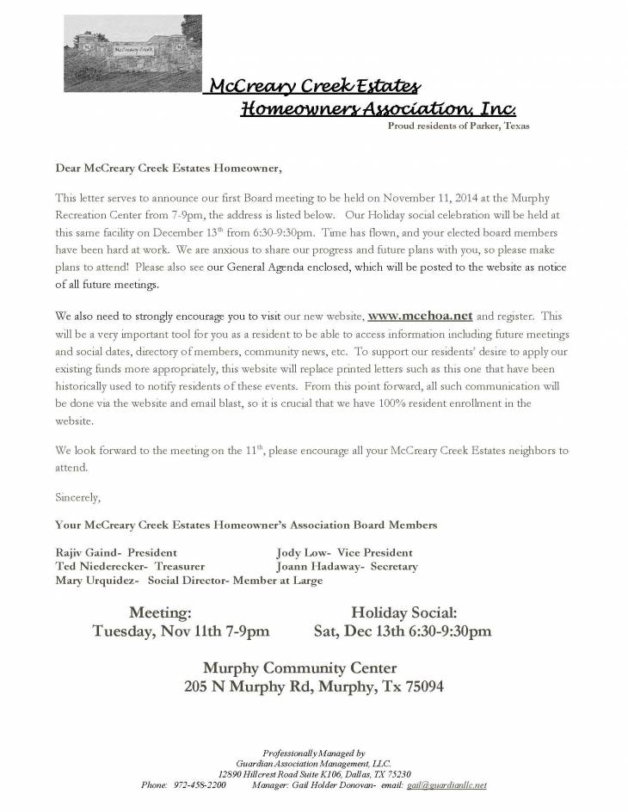
10/20/14 -
Mark your calendars! A few significant HOA events have been planned.
- The first HOA Board and Residents Meeting has been scheduled for Tue 11/11 @ 7:00P - 9:00PM and will be held at the Murphy Community Center. More details will be posted in the Calendar section of this website. Email blasts will be sent to folks registered on the site.
- An HOA Holiday Social Event is planned for Sat 12/13 @ 6:30P - 9:30P, also at the Murphy Community Center. Also see the calendar for this item and expect some emails with additional details as the date approaches.
- Jody
09/30/14 -
By vote, the following HOA Board Members were elected by the attending homeowners and via proxy:
- Rajiv Gaind 2 yr term 7210 Meadow Glen Dr.
- Joann Hadaway 1 yr term 7408 Meadow Glen Dr.
- Jody Low 2 yr term 7202 Meadow Glen Dr.
- Ted Niederecker 1 yr term 7409 Meadow Glen Dr.
- Mary Urquidez 2 yr term 7302 Meadow Glen Dr.
09/24/14 -
Posting this for everyone's convenience. The Transition meeting is confirmed with Guardian for Sept 30:
Jody
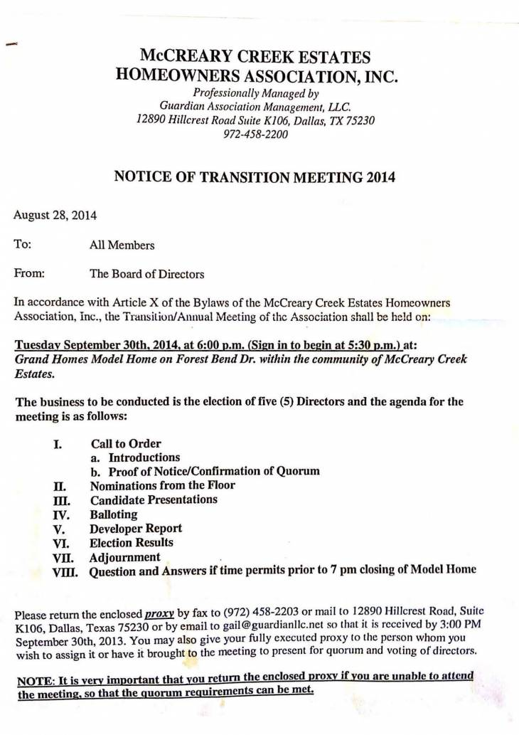
08/27/14 -
I received notification from Guardian that the HOA meeting is now tentatively postponed until the end of September.
- Jody
08/09/14 -
Kukie Boutte' has provided the following info:
Fyi, candidates for HOA Director so far - PARTIAL LIST:
KUKIE BOUTTE'
JODY LOW
TED NIEDERECKER
MARY URQUIDEZ
FRED WAMBO

Pages

- Home

- Calendar

- File Library

- Discussion Forums
- Photos

- Board Members

- Items for Sale

- Directory

- Weather

- Committees

- Useful Links

- Survey Results

- News Articles

News

City of Parker Police Non-Emergency Dispatch [a year ago]
7/2/15-Parker Non-Emergency Police Dispatch ServicePlease note that the phone number for non-emergency police dispatch has changed.The new number is 972-468-4236. More Info Read full article

New Survey - McCreary Creek Estates Community-Wide Garage Sale & Picnic [2 years ago]
5/26/15-New Survey - McCreary Creek Estates Community-Wide Garage Sale & Picnic Please take this survey to voice your preferences:http://www.mcehoa.net/login/takesurvey.html?id=ee7c58985aacc335495c3e1e5b9c6868 Read full article

McCreary Creek Estates HOA Board Meeting - Thurs, Apr 30th [2 years ago]
McCreary Creek Estates HOA Board Meeting - Thurs, Apr 30th McCreary Creek EstatesHomeowners Association ,Inc.HOA Board Meeting General Agenda MEETINGS OF THE BOARD OF DIRECTORS SHALL BE HELD AS CALLED BY THE BOARD OF DIRECTORS AND NOTICE SHALL BE GIVEN... Read more

Upcoming Events

Recalled Annual Meeting [December 15, 2016]
Time: 7pm
Location: Murphy Community Center
More info

